Life-Saving Drugs, V3

Chima D. Ndumele, PhD; Matthew P. Lavallee, BA; Anthony Lollo, PhD; Joseph S. Ross, MD,MS; Erica Spatz, PhD; Mark Schlesinger, PhD; Reza Yousebi, PhD; and Jacob Wallace, PhD;

From the Department of Health Policy and Management, Yale School of Public Health (Ndumele, Lavallee, Lollo, Ross, Schlesinger, Yousebi, Wallace); the Tobin Center for Economic Policy, Yale University (Lavallee); Center for Outcomes Research and Evaluation, Yale-New Haven Hospital (Ross, Spatz); Section of General Internal Medicine (Ross) and Section of Cardiology(Spatz),and Yale School of Medicine; all in New Haven, Connecticut

# Introduction

# Methods

## Overview

## Data Sources

We drew from five data primary sources. First, we use annual reports from the Center of Medicare & Medicaid Services (CMS) to collect state-level enrollment numbers for Medicaid and Medicare from 2004 to 2020. Second, we use the Behavioral Risk Factor Surveillance System (BRFSS) from the Centers for Disease Control and Prevention to estimate the proportion of individuals in each program with type 2 diabetes. Third, we use the National Drug Code Directory (NDCD) from the Food & Drug Administration to flag SGLT-2 and GLP-1 NDC codes. Finally, we use the State Drug Utilization Data (SDUD) and the Medicare Part D Prescribers dataset both made available by CMS, which provided state-by-year drug utilization numbers.

# Results

# Discussion

# X

## here() starts at /Users/mpl48/Documents/work/Drugs, Negligence, and Death

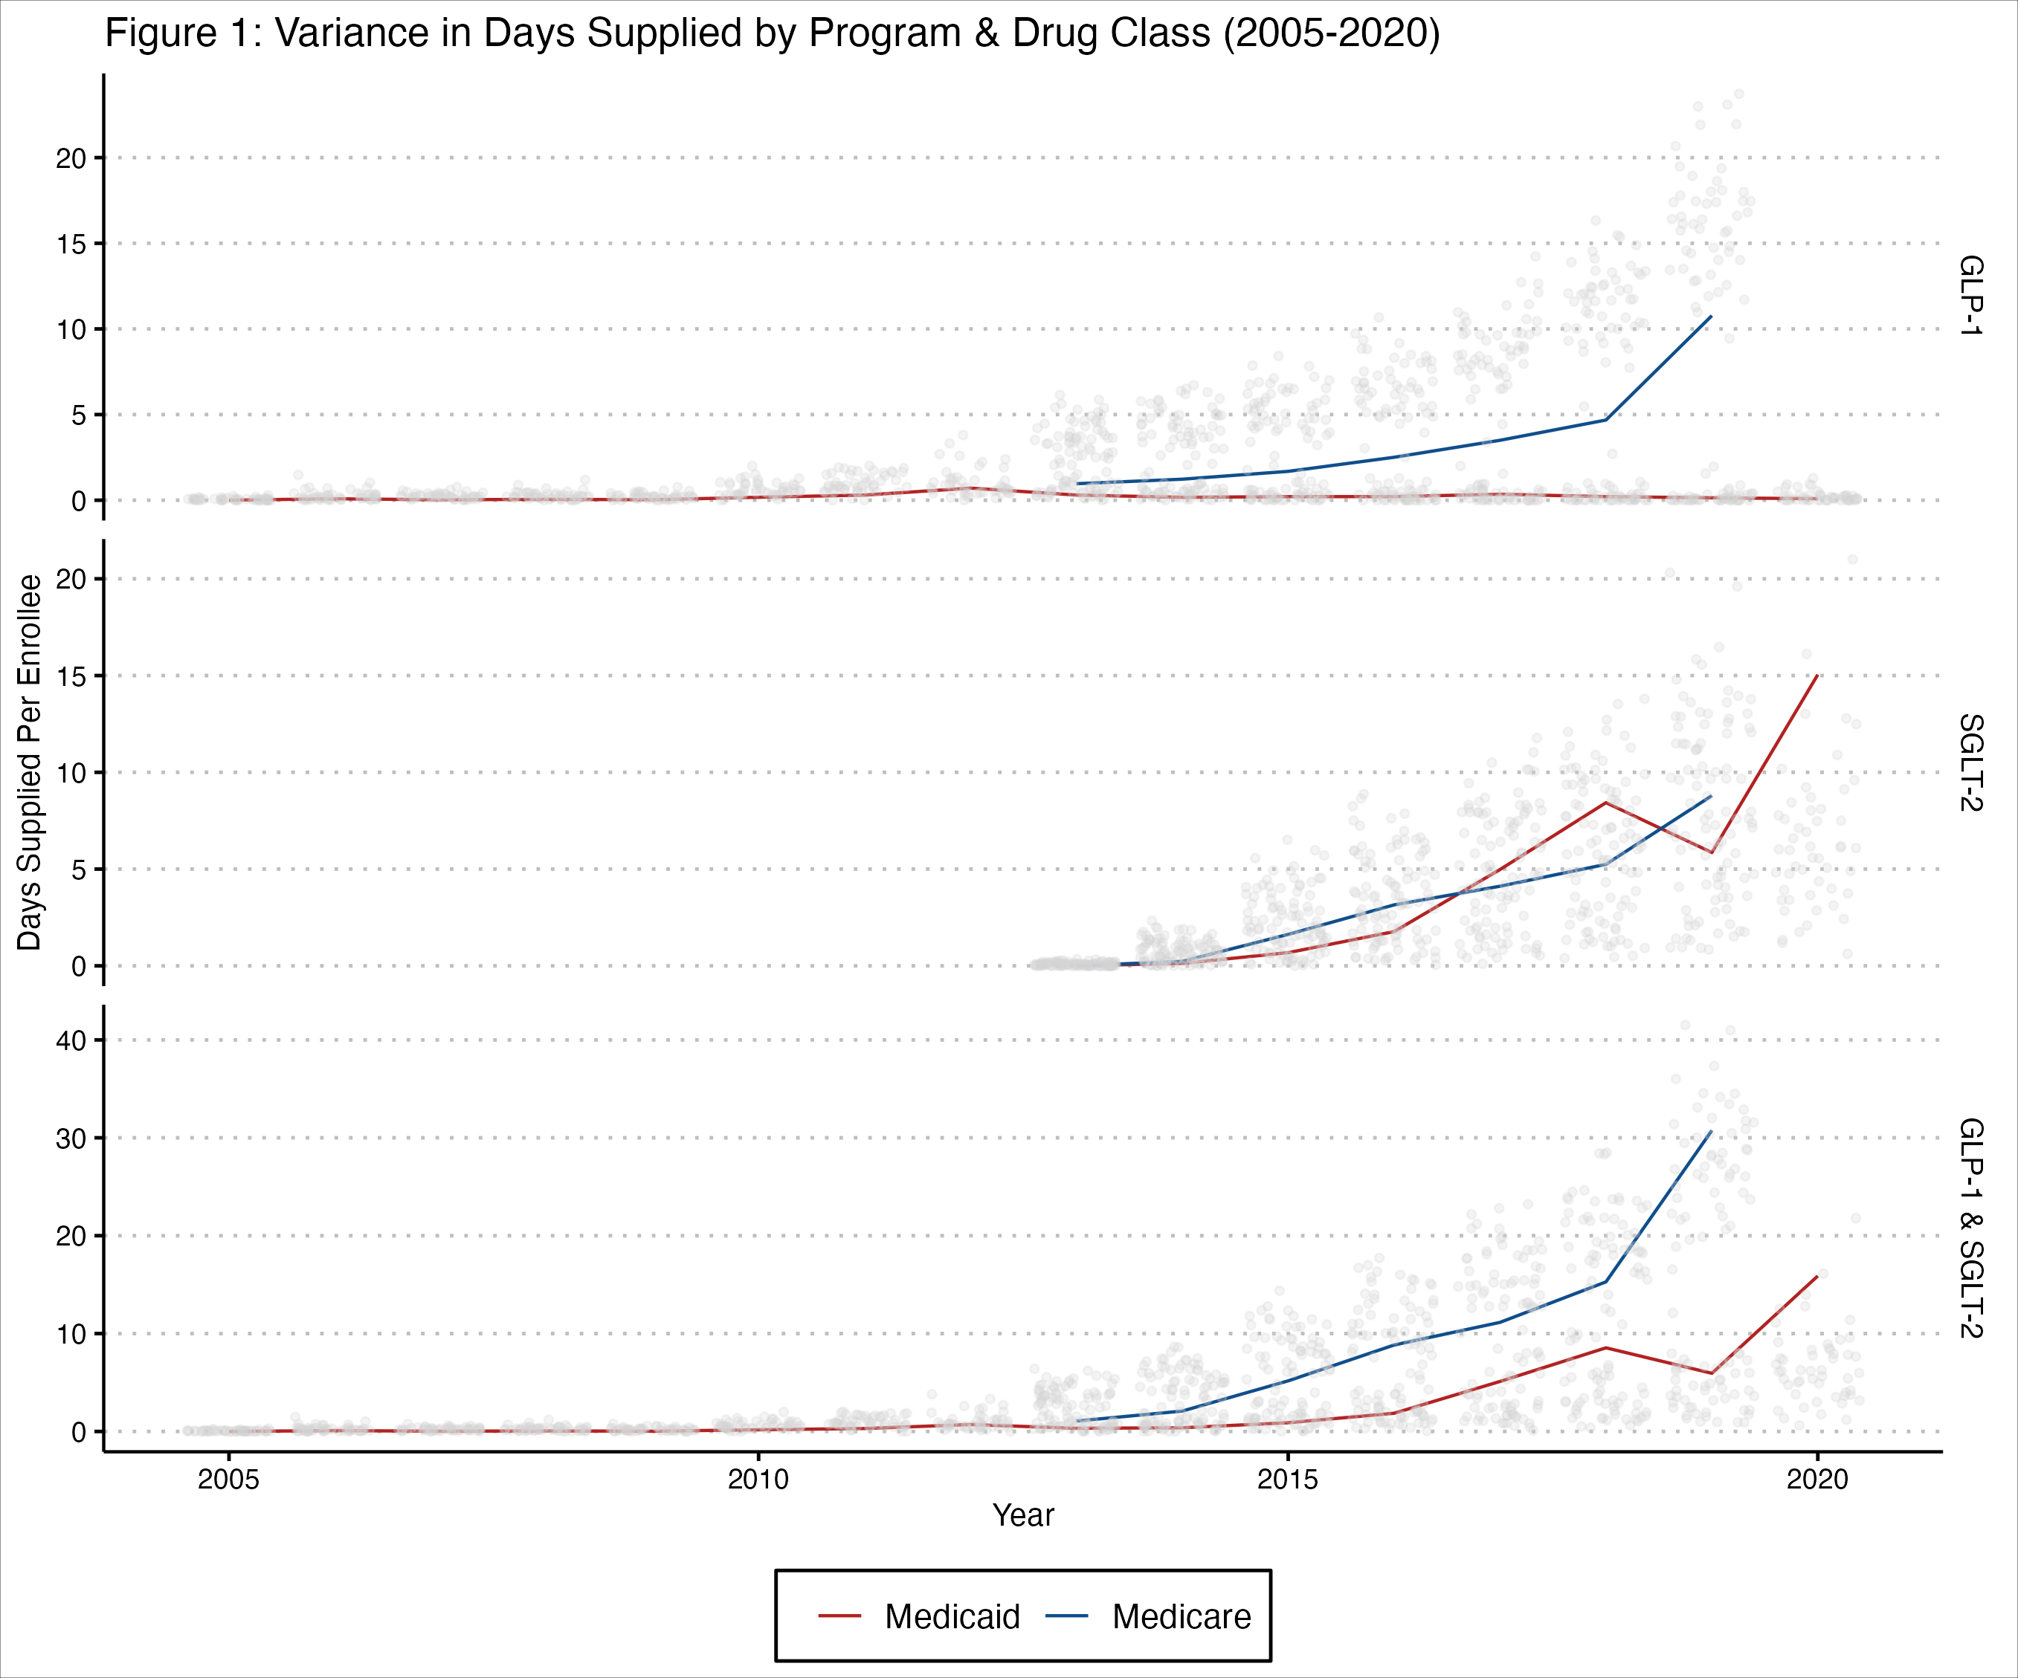

this is a caption

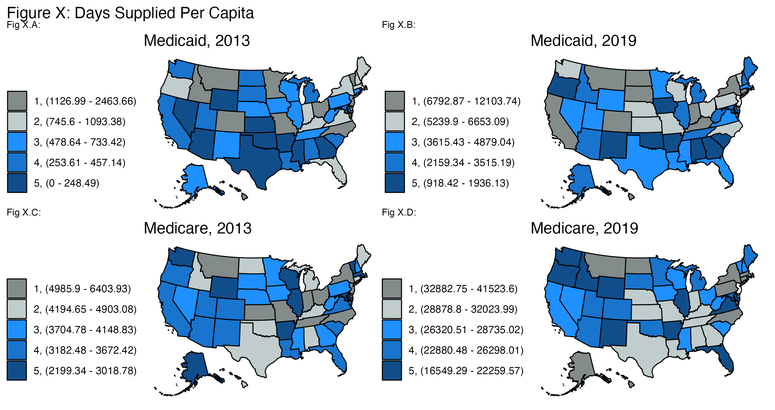

this is a caption

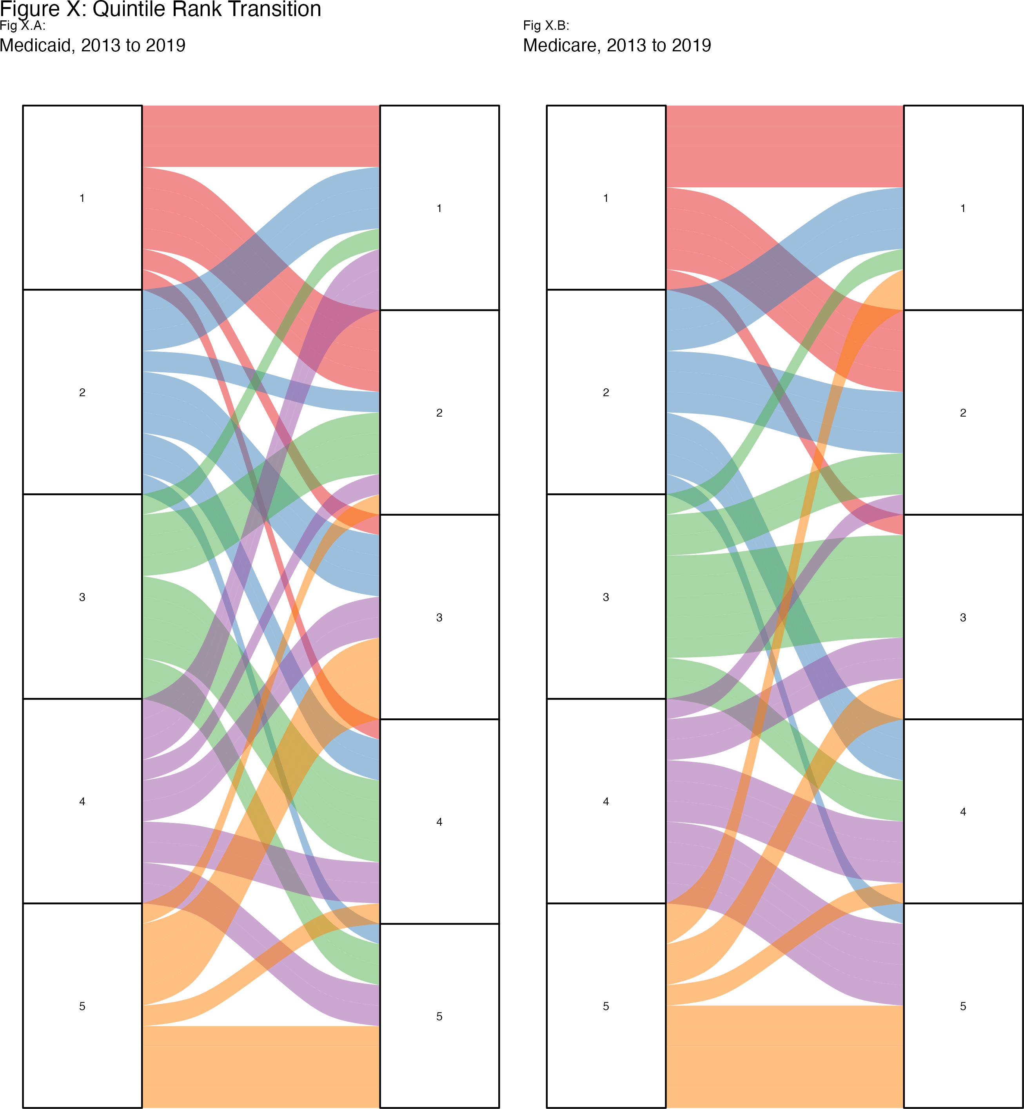

this is a caption

| Table X: GLP-1 & SGLT-2 Days Supplied | | | | |
| --- | --- | --- | --- | --- |
|  | Medicaid | | Medicare | |
| Year | Top Quintile | Bottom Quintile | Top Quintile | Bottom Quintile |
| 2005 | 168.37 | 0.79 |  |  |
| 2006 | 718.30 | 23.95 |  |  |
| 2007 | 500.67 | 44.75 |  |  |
| 2008 | 614.42 | 34.18 |  |  |
| 2009 | 487.46 | 23.33 |  |  |
| 2010 | 1,272.43 | 187.02 |  |  |
| 2011 | 1,780.21 | 290.66 |  |  |
| 2012 | 2,396.02 | 257.96 |  |  |
| 2013 | 1,632.08 | 125.45 | 5,563.53 | 2,686.69 |
| 2014 | 1,799.43 | 120.94 | 7,549.49 | 3,629.49 |
| 2015 | 2,906.06 | 275.59 | 11,975.44 | 5,743.98 |
| 2016 | 4,172.17 | 529.47 | 15,996.42 | 7,913.61 |
| 2017 | 6,812.94 | 771.81 | 20,682.61 | 11,784.82 |
| 2018 | 8,529.77 | 1,030.28 | 25,154.99 | 14,724.97 |
| 2019 | 7,838.45 | 1,380.35 | 35,851.19 | 20,432.88 |
| 2020 | 12,427.55 | 2,199.14 |  |  |

| Table X: GLP-1 & SGLT-2 Days Supplied | | |
| --- | --- | --- |
|  | Mean (SD) | |
| Year | Medicaid | Medicare |
| 2005 | 59.53 (66.64) |  |
| 2006 | 260.98 (291.09) |  |
| 2007 | 243.18 (164.35) |  |
| 2008 | 274.17 (229.46) |  |
| 2009 | 210.01 (169.99) |  |
| 2010 | 646.15 (416.76) |  |
| 2011 | 993.76 (549.07) |  |
| 2012 | 1009.22 (840.7) |  |
| 2013 | 724 (569.23) | 4022.79 (1030.05) |
| 2014 | 841.83 (615.03) | 5604.57 (1443.51) |
| 2015 | 1443.24 (944.51) | 8753.49 (2273.94) |
| 2016 | 2103.56 (1363.75) | 11746.74 (2971.8) |
| 2017 | 3186.49 (2260.46) | 16004.66 (3338.64) |
| 2018 | 3990.88 (2923.16) | 19989.81 (3909.21) |
| 2019 | 4446.04 (2437.61) | 27876.22 (5545.62) |
| 2020 | 6706.73 (3986.11) |  |

| Table X: GLP-1 & SGLT-2 Days Supplied | | | | | |
| --- | --- | --- | --- | --- | --- |
| Year | Top Quintile | Second Quintile | Third Quintile | Fourth Quintile | Bottom Quintile |
| 2013 | 3597.81 (2064.19) | 2753.84 (1889.92) | 2218.54 (1684.32) | 1890.71 (1573.7) | 1406.07 (1326.03) |
| 2014 | 4674.46 (2984.28) | 3737.27 (2783.57) | 3096.22 (2485.01) | 2587.69 (2172.84) | 1875.22 (1833.83) |
| 2015 | 7440.75 (4701.5) | 5819.38 (4187.83) | 4871.97 (3713.86) | 4115.72 (3348.16) | 3009.78 (2853.54) |
| 2016 | 10084.3 (6106.52) | 8008.91 (5569.89) | 6534.64 (4860.48) | 5460.46 (4395.28) | 4221.54 (3853.85) |
| 2017 | 13747.77 (7216.39) | 10870.87 (7149.17) | 8972.25 (6634.71) | 7693.46 (6324.62) | 6278.32 (5755.86) |
| 2018 | 16842.38 (8764.92) | 13529.07 (8902.85) | 11282.9 (8439.22) | 9934.55 (8172.25) | 7877.62 (7178.14) |
| 2019 | 21844.82 (14573.03) | 18336.22 (12689) | 15898.33 (11990.9) | 13819.66 (11350.12) | 10906.62 (9853.33) |

| Table X: Program Characteristics by Quintile | | | | | | |
| --- | --- | --- | --- | --- | --- | --- |
| Program | Variable | Top Quintile | Second Quintile | Third Quintile | Fourth Quintile | Bottom Quintile |
| Medicaid | Rate of Days Supplied per 1000 Enrollees | 4815.06 (2911.09) | 3015.52 (1879.55) | 2023.61 (1265.03) | 1316.58 (849.72) | 604.84 (523.54) |
| Population of Program | 207211.57 (284154.87) | 109967.2 (164785.28) | 137551.05 (141628.2) | 152790.84 (195932.59) | 104515.87 (91039.55) |
| Percent Diabetic in Program | 9.89 (2.44) | 10.34 (2.15) | 10.68 (2.27) | 10.59 (2.6) | 11.81 (2.32) |
| Medicare | Rate of Days Supplied per 1000 Enrollees | 17454.61 (9849.54) | 15000.36 (8666.71) | 13083.49 (7852.09) | 11684.06 (7207.02) | 9559.49 (6140.84) |
| Population of Program | 275157.3 (225669.69) | 241176.22 (248919.28) | 303782.49 (341169.92) | 208194.27 (224878.24) | 158641.36 (185623.53) |
| Percent Diabetic in Program | 21.26 (2.69) | 22.2 (3.05) | 21.4 (3.04) | 20.58 (2.81) | 20.09 (2.29) |

| Table X: Program Characteristics by Quintile | | | | | | |
| --- | --- | --- | --- | --- | --- | --- |
|  | | Mean (SD) | | | | |
| Program | Variable | Top Quintile | Second Quintile | Third Quintile | Fourth Quintile | Bottom Quintile |
| Medicaid | Medicaid Spending (Total, Millions of $) | 11616.31 (14971.96) | 6024.86 (8368.19) | 7261 (6823.53) | 7146.19 (8260.81) | 4824.56 (4303.41) |
| Medicare Spending (Total, Millions of $) | 13258.45 (14225.28) | 8199.21 (9807.1) | 11513.91 (12682.75) | 10297.85 (11219.05) | 7335.82 (6581.42) |
| Medicaid Spending (Per Capita, $) | 7988.53 (1648.84) | 7344.01 (1355.1) | 7420.76 (1927.01) | 6681.31 (1498.2) | 6568.4 (1530.72) |
| Medicare Spending (Per Capita, $) | 10013.24 (1309.41) | 9613.51 (1003.15) | 10131.13 (1363.59) | 9768.3 (1234.89) | 9804.77 (862.86) |
| Enrollment | 207211.57 (284154.87) | 109967.2 (164785.28) | 137551.05 (141628.2) | 152790.84 (195932.59) | 111725.99 (91968.61) |
| Total Federally Qualified Community Health Clinics | 131.87 (152.62) | 90.5 (96.36) | 118.77 (90.85) | 134.77 (125.98) | 101.16 (63.78) |
| Total Federal Medical Doctors | 546.39 (623.22) | 380.67 (463.19) | 593.41 (636.49) | 550.64 (601.1) | 382.55 (409.07) |
| Medicare | Medicaid Spending (Total, Millions of $) | 10571.81 (13341.53) | 6251.9 (6708.96) | 8916.91 (11621.02) | 6681.68 (8054.68) | 4594.99 (3806.72) |
| Medicare Spending (Total, Millions of $) | 12143.8 (10596.92) | 9404.26 (9689.68) | 13193.99 (15878.44) | 9416.04 (10804.9) | 6583.68 (7774.37) |
| Medicaid Spending (Per Capita, $) | 7943.49 (1707.8) | 6890.71 (1449.65) | 6890.9 (1507.55) | 6862.43 (1474.76) | 7469.93 (1961.41) |
| Medicare Spending (Per Capita, $) | 10329.83 (1192.55) | 9896.48 (1115.08) | 9987.18 (1192.3) | 9792.19 (1158.23) | 9279.61 (1032.51) |
| Enrollment | 275157.3 (225669.69) | 241176.22 (248919.28) | 303782.49 (341169.92) | 216708 (226167.83) | 164974.11 (187275.99) |
| Total Federally Qualified Community Health Clinics | 108.91 (70.46) | 116.04 (82.46) | 151.44 (171.97) | 115.75 (129.12) | 86.57 (62.99) |
| Total Federal Medical Doctors | 455.21 (391.14) | 422.8 (513.69) | 595.17 (756.54) | 571.24 (630.06) | 425.69 (438.14) |